Salem (D.T), 636 111.

Mettupatti (P.O), Valapady (T.K),

Attur main road,

Address of Institution :

Ganesh college of Engineering,

Name of Institution :

Ganesh college of Engineering

B.K.KARTHIKEYAN

M.PERUMAL

G.THAMARAISELVAN

SUBMITTED BY : P.NAVEEN

THEME : SMART WATER FOUNTAINS



16.

Acknowledgment

15.

Reference

14.

Result

13.

Ethics and Safety

12.

Risk Analysis

11.

Control Unit

10.

Mechanical Unit

9.

Power Supply Unit

8.

Display unit

7.

Sensor Unit

6.

Design

5.

High-level requirements list

4.

Physical Design

3.

Background

2.

Objective

1.

Introduction

S.NO

CONTENTS

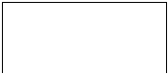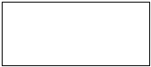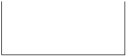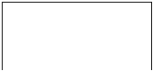

owners to leave home for several days without worrying about water supply for pets.

sufficient water source as well as automatic replacing and refilling function enable pet

for long-term usage. The link is adaptable to universal water bottles for convenience. The

Our water fountain can be connected to an extra water source that provides enough water

enough water for multiple pets to drink in several days.

water fountain limits the capacity of the water source that most water fountains cannot store

have only filtration as an extra function besides providing running water. The size of the

There have been quite a lot of water fountain products on the market, while most of them

1.2 Background:

pumped through the submersible water pump.

“Bad”. The water fountain is also designed to self-filter the water every time when water is

will be collected, calculated, and reflected to the user in terms of “Good”, “Average” and

be the three properties used for calculating water quality in our water fountain. These data

home can only affect limited factors, we choose temperature, Ph-value and conductance to

temperature, Ph-value, conductance, turbidity and hardness. Considering the pollution at

to measure the water quality. Common water quality measurement factors include

automatically replace water when polluted(not healthy) or running out. We will use sensors

Our goal is to design a smart water fountain that can monitor the water quality and

These can cause the pet to be unwilling to drink water from the fountain.

remaining water in the water fountain, or water has been polluted somehow by the pet.

we are away from home for several days. It can happen when pets have finished all

households having cats or dogs as pets. However, we can not ensure the water quality when

long-term health for pets, especially cats. As a result, a water fountain is essential to most

encourage pets to drink. Drinking a certain amount of water daily plays an important role in

Both cats and dogs prefer flowing water. A source of fresh clean running water can

households own a dog globally and about a quarter of households worldwide own a cat.

about 80% of all pets. Same trend happens all over the world. On average, one in three

Breakdown of the pet types, cats and dogs are the most popular animals, they contribute to

about 84.9 million homes. This proportion has been increased by 20% in thirty years.

Pet Products Association’s survey in 2020, 67% of U.S. households own a pet which is

Today, more people around the world have pets than ever before. According to American

1.1 Objective:

Introduction

1.



water will be drained by a motor-controlled valve to the “polluted water temporary storage

• Able to drain the polluted water and replace it with fresh water. Specifically, the polluted

1.4 High-level requirements list:

Figure 1 Smart Fountain Physical Diagram

not a breakdown of inner components.

phone). Note that this is not a block diagram and should explain how the solution is used,

solution connects to a phone via Bluetooth, draw a dotted line between your device and the

restricted to your design. Include other external systems relevant to your project (e.g. if your

A pictorial representation of your project that puts your solution in context. Not necessarily

1.3 Physical Design:

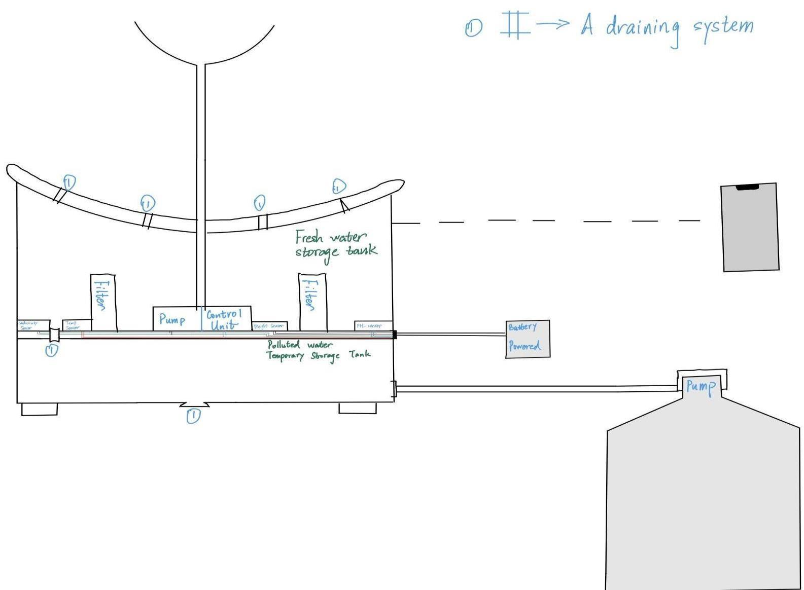

to the control unit. Control unit will then have some logic designed to send corresponding

This block contains the four sensors. The data acquired from the sensors will be transmitted

2.1 Sensor Unit

Figure 2 Block Diagram of Smart Water Fountain

Details of each unit is presented in the diagram and described in the next section.

modules, including Power Supply, Control Unit, External Control, and Mechanical Unit.

The block diagram below is a general design of our solution. We divide our design into four

Design

2.

water level and water quality index: ‘Good’, ‘Average’ and ‘Poor’.

smart water fountain to users’ interface with relevant information including the remaining

• Able to be connected to the users’ devices through WIFI. Prompt feedback from the

temperature up to 48.89C and pH values between 6.5 and 8.5.

• The fountain must accurately monitor the water quality, including measuring water

1).

general water supply(as described in the right down corner of the physical design, Figure

tank” part. After completing the draining process, fresh water will be pumped from the

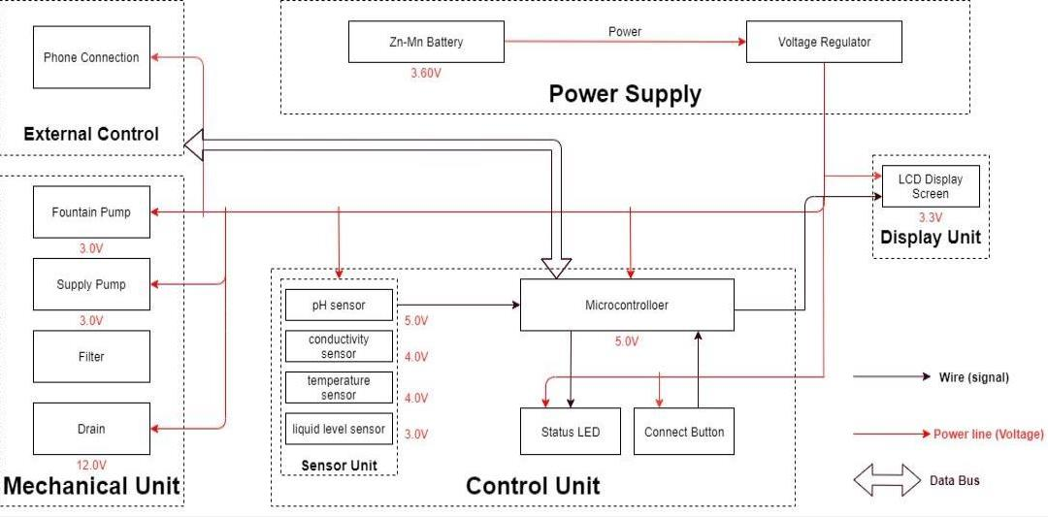

freshwater left can be determined.

inches, the corresponding sensor outputs readings from 0 to 1.6. From that, the quantity of

fountain keeps running with freshwater. This sensor is 0.5 Watts. For water level from 0 to 9

the water level is low, fresh water will be pumped to the water tank to ensure the water

This sensor is responsible for reflecting how much freshwater is left in the water tank. When

2.1.4 Liquid Level Sensor:

which is enough for water quality monitoring.

3.0 to 5.0V. The error is small, +-5%F.S. The measurement value ranges from 0 to 20 ms/cm

Conductivity sensor is also part of the water quality assessment. The input voltage is from

2.1.3 Conductivity sensor:

with an accuracy of +- 0.1 at the temperature of 25 degrees.

is also compatible with the temperature sensor. It can 6measure the PH value from 0 to 14

PH value is a valued indicator of water quality. This PH-sensor works with 5V voltage, which

2.1.2

PH-sensor:

fulfill all requirements needed for this project.

degrees. Between -10 to + 85 degrees, the accuracy is up to +-0.5 degrees. This sensor can

supply from 3.0V to 5.5V. The measured temperature ranges from -55 to +125 celsius

DS18B20. This temperature sensor is compatible with a relatively wide range of power

A water-proof temperature sensor is going to be used. Part number from sparkfun is:

2.1.1 Temperature Sensor:

readings will be used to determine the amount of fresh water left in the water tank.

is determined, the water replacement procedures will take place. The weight sensor

retrieved and calculated to determine the overall water quality level. When poor water quality

For the PH-value sensor, temperature sensor and conductivity sensor, values will be

remaining water quantity.

the water fountain will display the readings along with the determined water quality level and

signals to control other blocks of the water fountain. At the same time, the display screen on



or replacement under heavy workload.

Requirement 2: The fountain pump must serve for a duration of 2 years without maintenance

height of 400mm.

Requirement 1: The fountain pump must lift a cylindrical water stream of diameter 6mm for a

turns off the power supply.

mechanism. The pump must work 24 hours a day, 7 days a week unless the user manually

The fountain pump [14] must maintain a continuous water supply through the fountain

2.4.1 Fountain Pump

2.4 Mechanical Unit

Requirement: Must maintain thermal stability below 100°C.

(3.60V ± 0.5V) while ensuring the voltage at each module does not exceed their limit.

functionality. This chip must be able to handle the maximum voltage supplied by the battery

The integrated circuit will regulate the power supply for each module to maintain their

2.3.2 Voltage regulator

outlets will be considered.

supply for at least 24 hours. If the chosen battery is not powerful enough, 120V power

Requirement: Commercial batteries will be used to maintain a continuous 3.60V power

unit, and the mechanical unit.

The Zn-Mn battery must be able to continuously support the functioning of the circuit, display

2.3.1 Zn-Mn Battery

2.3 Power Supply Unit

displayed along with the remaining water level.

programming the screen, a conclusion of water quality(Good, Average, Poor) will be

This 20\*4 LCD display screen is going to be used to display the relevant information. After

programmed so that it makes it easy for users to read information.

the water quality and remaining water quantity will be displayed. The screen will be

addition, other necessary information will also be displayed. As described in the sensor part,

The screen will be used to display the readings from the sensors in a real-time manner. In

2.2.1 Screen:

2.2 Display unit:



described above in the display unit.(unsure about keeping this function)

• Water quality result is sent to the user with wireless connection and screen display as

water in the fountain and then control the water supply to refill.

• If the water quality is “Bad”, the control unit will control the drain module to drain the

quality module and sends the result in terms of “Good”, “Average” or “Bad” to the user.

• Computes the water quality with data transferred from the three sensors in the water

the water fountain with a certain amount of water.

control unit will send an alert signal to the user and then control the water supply unit to refill

• When the weight sensor reports a weight less than the minimum weight setting, the

This unit contains the control unit which does the following things:

2.5 Control Unit

instruction is received from the integrated circuit.

fountain should be replaced, the faucet should automatically drain the fountain once

The drain [13] must be able to hold and release water in the fountain. When water in the

2.4.4 Drain

connection mechanism must have a low degenerate rate when submerged in water.

Requirement 2: The filter must be designed for easy removal and installation, while the

new filter must serve a duration no less than 3 month.

Requirement 1: The filter must have a cost less than $5 each for frequent replacement. Each

the water.

The filter must maintain the water quality through controlling the pH value and conductivity of

2.4.3 Filter

Requirement: The supply pump should have an operational condition around 3V, 200mA.

is requested, the pump must prevent water flow between the main supply and the fountain.

The supply pump must function when a low water level alert is raised. While no water supply

2.4.2 Supply Pump

Requirement 3: The fountain pump should have an operational condition around 3V, 200mA.



in.

actual building process for the container should be proved before placing the electronic parts

To achieve those points, we will make sure the designs are carefully implemented. The

consumption will be uncontrollable.

Otherwise the fresh water will be leaking to the polluted water storage and the water

the motor-controlled valves used to drain the polluted water need to be firm when closed.

mechanical parts. This puts pressure on the design and also the implementation. In addition,

water tank. This means that we need to ensure no water can leak into the electrical-related

exposed to water. Sensors, pumps, filters, draining system motors are all to be placed in the

This is very challenging and extremely important. As most of the components will be

2.6.2 Mechanical Unit Block:

users’ phones through WIFI.

part will also be responsible for building the connection between the water fountain and the

control unit to the screen, displaying the necessary information as described above. This

integrate all the data to produce a credible result. The data delivering is used to connect the

Data manipulation is the process of calculating the water quality levels, and the formula to

Necessary algorithm is to be written to ensure successful and accurate data acquisition.

manipulation, data delivering. Data retrieving is the logic used to read data from all sensors.

We will divide all the overall control unit functions into three parts: data retrieving, data

risk.

these are all to be performed by the control unit. Thus, it is the block that brings the greatest

and then sending signals to activate the corresponding actions(drain or add fresh water),

the data from sensors, analyzing the data, communicating and displaying the data to users,

part so that the pumps, draining system can work collaboratively smoothly. From acquiring

sensors is the key. The control unit needs to accommodate the mechanical and the electrical

between different blocks. To react accurately and promptly based on the results from the

One of the most challenging points in this project is the precise control of the control unit

2.6.1 Control Unit Block:

2.6 Risk Analysis:



safety of people and property to the largest extent.

with emergency situations. In case of accidents, proper reaction will be made to ensure the

“Laboratory Safety training” and have gained required and necessary knowledge in dealing

All team members involved in the development of the water fountain have completed

disclosure of pertinent limitations.”

technological tasks for others only if qualified by training or experience, or after full

Quoted from [11]: “to maintain and improve our technical competence and to undertake

3.1.3 I-6 of IEEE Code Of Ethics:

taken to ensure the safety of using the water fountain and protect the others.

responsible for testing and ensuring all containers meet the demand. These actions must be

not performed properly. To maintain a safe, convenient using experience, we will be

physically placed in the water tank. The consequence can be serious if the leakproofness is

As mentioned in the 3.2, the mechanical unit involves electronic components that are

harassment or discrimination, and to avoid injuring others.”

Quoted from [11]: “II. To treat all persons fairly and with respect, to not engage in

3.1.2 II of IEEE Code Of Ethics:

convenience, and reduces the future cost when using the water fountain.

complies with the IEEE Code of Ethics #I-1. It not only improves the practicality,

bottle can be recycled and reused. This is the most environmentally-friendly solution and

the universal connection is to be used. After the water in the bottle is used up, this reusable

universal water bottles are safe and reusable. [12] A special connector will be designed and

buy reusable bottles of water for the freshwater supply for the water fountain. Those

used. We will prefer using reusable materials. In addition to that, the users can choose to

We will carefully choose the materials used to build the container. Non-toxic are sure to be

or the environment.”

protect the privacy of others, and to disclose promptly factors that might endanger the public

the public, to strive to comply with ethical design and sustainable development practices, to

Quoted from IEEE Code of Ethics[11]: “To hold paramount the safety, health, and welfare of

3.1.1 I-1 of IEEE Code of Ethics:

3.1 Mechanical Unit Block

Ethics and Safety

3.



We thank naan mudhalvan team and IBM team and our faculties for their supports.

Acknowledgement:



RESULT:

This we concluded by above idea to archieve a massive revolution in smart water fountains system.